COMP400725
Lab Book 5

➔ Create a folder called Lab5 in your COMP40725 folder. You may wish to have this inside a folder that is being synced by Google Drive.
➔ Use Notepad++ or TextWrangler to write SQL queries. Test these queries in your Oracle 11g XE Database system. You can either use SQL Command Line or Oracle Web Interface to test your queries. Do not use MySQL as the commands will not work.
➔ Use comments in your sql queries: -- is for a single line, and /*... */ for multiline.
➔ Submit this document with the following name “Lab5_LastName_FirstName_StudentNumber”.

NB. Web links in PDF version of document may be corrupt.

Please complete this practical using the web interface for Oracle. See “How to Launch Oracle and Execute SQL Commands” document on Moodle.

This lab requires you to create and test the following queries.

- Run the example SQL DDL/DML code provided in Customer.sql available on Moodle. Please note you must cut and paste this into the SQL Command editor in the online Interface of Oracle. It will create 3 tables and populate them with data. Read the code so you understand the tables, columns, and their relationships. Enter the create table commands one at a time and then use the following to save time
BEGIN
<All your insert statements>
END

[There is no requirement to paste information here]

- Create a query that lists each order number (CUST_ORDER table) with the first name and surname of the employee associated with the order.

**Note: Comments are shown in SQL queries generated in TextWrangler prior to performing commands in Oracle SQL, as the system produced some errors with the comment notations.

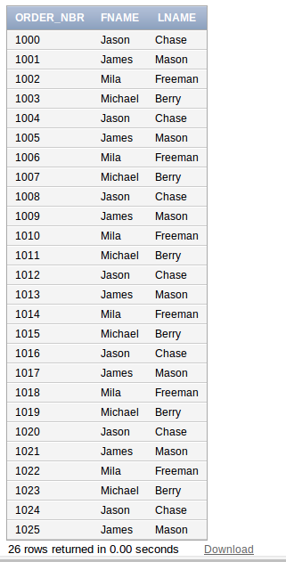

- Create a self-join on the employee table, where the results should show each employee's name and their manager's name. Rename the columns in the results to be more appropriate.

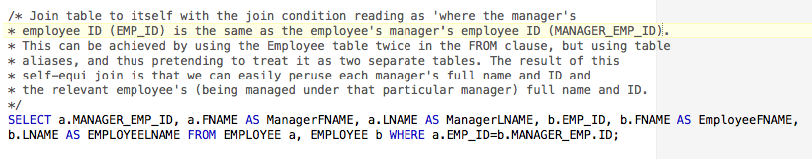
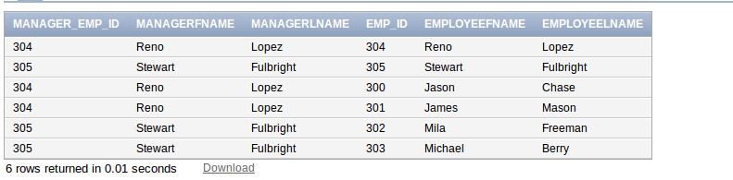

- Use an outer join to list all employees’ first name and surname with the customer order's (ORDER_NBR) they are associated with (i.e. sales_emp_id in the CUST_ORDER table). As it is an outer join, it should also list employees that have never had a sale.

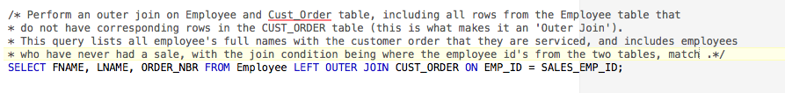
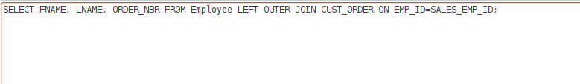
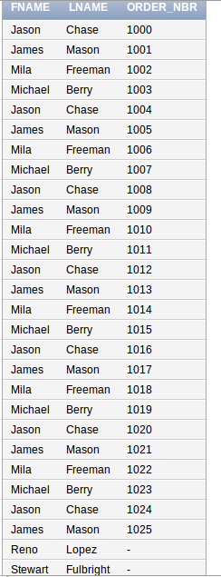

- Create a query to display the total sales price of all orders (i.e. 1 value).



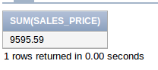

- Create a query to display the average sale_price of an order by each employee.

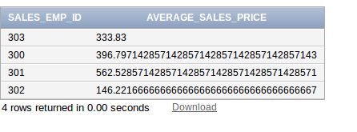

- Create a query to display the total sales price of all orders from each customer.
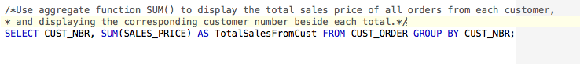

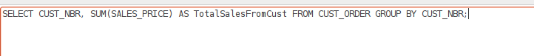
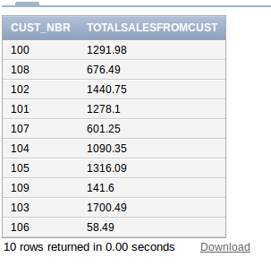

- Create a query to display the total sales price of all orders from each customer - where only customers who spent more than 1000 are considered.

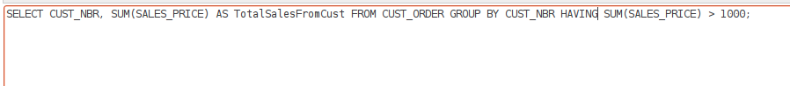
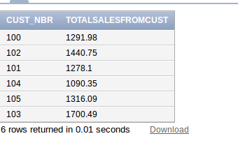

- Demonstrate the use of a CUBE query on two columns (from any 2 tables in the sample database -can be same as lecture example if you add a category column in the part table).

(See next page for table)
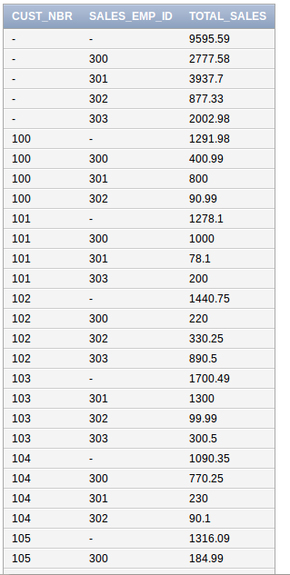
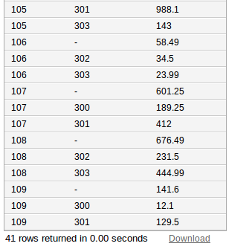

- Demonstrate the use of the ROLLUP query on two columns different to those in the CUBE query above.
